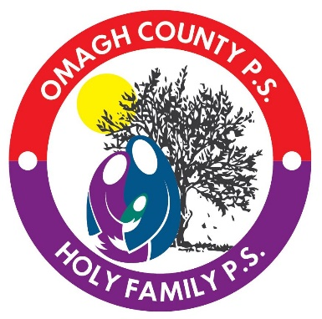

**Shared Education**

**2019-2020 Term 1**

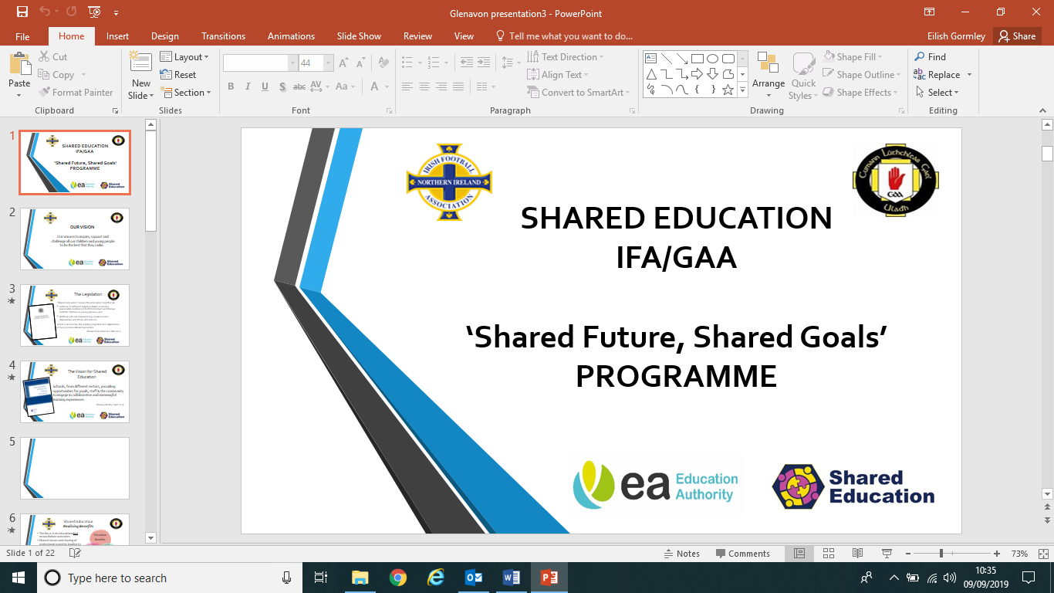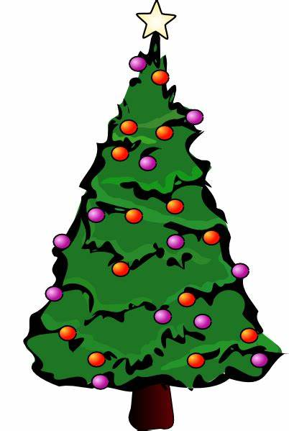

Year 4 pupils are involved in a 10-week programme promoting Health and Well-being in collaboration with I.F.A/ G.A.A.

Omagh County P.S. and Holy Family P.S. are celebrating 30 years of Shared Education. As part of these celebrations, the joint choir are performing at the Strule Arts Centre 10th December.

Teachers have been involved in joint planning for their classes and curriculum areas, including ICT and play.

9th October- Year 3 visit to Omagh Library.

8th November- Year 4 visit to the Folk Park ‘Yesterday’s Children.’

12th and 19th November- Year 6 PE lessons with Burns Skills School

13th and 14th Nov- Year 5 Icebreaker Days

4th December- Year 2 Omagh County P.S. visit Holy Family Christmas Play

5th December- Year 4 Omagh County P.S. visit Holy Family Christmas Play

11th and 13th Dec- Year 1 classes visit An Creggan for ‘A Green Christmas’

18th December- Year 3. Holy Family visit Omagh County P.S Christmas Play