Holy Family P.S.
Policy for

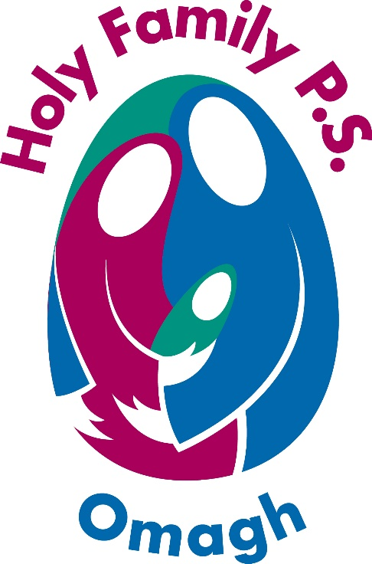

Vision/Mission
Statement

Vision/Mission Statement & School Aims

Vision/Mission Statement:
We believe children learn best when they are happy, feel valued and are encouraged within a safe, positive and stimulating learning environment.
We believe in the holistic development of every child in order for them to reach their full potential and become independent, lifelong learners.

Aims:
The Holy Family Primary School aims to provide a Catholic education, which seeks to foster the growth of the whole child and to help them realise their unique God-given potential. Although we are a Catholic school we warmly welcome pupils of all nationalities and religious denominations and value and respect the rich cultural diversity they bring to our school. Our caring staff is dedicated to providing a sound education, in an atmosphere where Christian values are clearly lived and where the growth of the whole child is fostered.

Each child experiences a broad, balanced curriculum in line with the Revised Northern Ireland curriculum. Subjects include Religion Education, Language & Literacy (English), Numeracy (Maths), The World Around Us (Science, Geography & History), The Arts (Music, Art and Drama), PDMU. The curriculum is further enriched with cross-curricular themes (I.C.T, Health Education, Shared Education and developing Thinking Skills and Personal Capabilities. All pupils also have an opportunity to engage in a wide range of after school clubs and sports e.g. gaelic, netball, soccer, hurling, camogie and cross country running. All staff aim to provide a stimulating learning environment where a spirit of enquiry and enthusiasm for learning is cultivated.

Policy Statement of the General Aims of the School

1. To provide a Catholic education in an environment where:

- We strive to give each child a sense of worth and help them realise their unique God-given potential.
- Christian values are actively lived.
- The growth of the whole child is fostered.
- Each will receive a broad and balanced education as prescribed by the N.I. Curriculum
- Each can avail of a full wrap-around care facility e.g. breakfast club, wide range of after school activities, pre & after school care

2. To foster an atmosphere of safety, trust, acceptance and co-operation
where:
- Children’s self esteem is developed and they are encouraged and helped to communicate clearly and confidently.
- Children are encouraged to treat everyone with respect and grow to be responsible members of both our school and local community.

3. To have a real care for the less able and underprivileged, so that they may develop their capacity, their talents and gifts.

4. To provide the opportunity for children to:

- Reach their full learning potential through the N.I. Curriculum and our Extra Curricular Programme
- Acquire knowledge of the world in which we live in order to develop the children’s ability to become contributing members of the community in a local and international context.
- Learn how to apply computative skills with speed, accuracy and understanding.
- To cultivate the creative arts and promote a healthy lifestyle, sport & leisure.

5. To foster and keep alive in our pupils the spirit of enquiry, wonder and enthusiasm in the process of learning characteristic of primary school children.

6. To foster and develop links with the parents, the parish and the local community.

7. To foster and develop links with other schools in a European and global context so that our pupils have a greater awareness and understanding of the world we live in.

