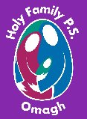
Holy Family Primary School
Newsletter
Friday, 12th April 2024
Pupils of the Week
Class | Name | Reason
Reception | Daniel Fegan &  Carson Moore | For being kind & gentle with each other
Yr.1 NC | Raisa Maria Tigau | For making a super junk art rocket!
Yr.1 MP | Dáithí Curran | For creating an amazing rocket using junk materials – wow!!
Yr.2 EM | Ryan Harte | For his impeccable manners. He always uses please & thank you. Good boy!
Yr.2 FMG/NC | Sophie McTeague | For working so hard and being kind and helpful to others
Yr.3 SM | Elena Eccles | For selflessly giving up her touch screen computer to another pupil who was finding it tricky to use the mouse!!
Yr.3 MC | Matthew Deehan | For being so imaginative & creative with his writing this week – keep it up Matthew!!
Yr.4 CMM | Rhian Mamalis | For settling in so well to Yr.4
Yr.4 BH | Antonina Pospiech | For fantastic multiplication of a 2 digit number by a single digit!
Yr.5 DMC | James Doyle | For great work on ‘time’.
Yr.5 DMS | Fianna Meenan | For working very hard with a very positive attitude
Yr.6 SMG | Alan Bedkowski | For always being so positive and pleasant
Yr.6 ZMD | Fabian Clarke | For his great work ethic
Yr.7 CK | Cara McVey | For always working consistently hard
Yr.7 KMK/AC | Annemarie Gormley | For settling in so well since returning to Holy Family

Good Manners Award
Those chosen to receive recognition for the ‘Good Manners’ Award this week are:
Junior Site: Sophie Mahon, Eve Sloan, Matteo Bogos, Mark Kleshnia, James McElroy, Naomi McDonagh, Sean McCanny, Monica Nugent, Sean Timoney, Ellen McDermott, Matthew Grugan & Aibheen Burns.
Senior Site: Charlie McCoy, Jessica McCaul, Blaithín Timoney, Niamh Woodhead, Rose McCann, Charlie Kelly, Dara McCaffrey & Myah Donnelly.
Well done everyone, we are so proud of you all.

Healthy Eaters!
Junior Site: Tess McMackin, Thielen Douglas, Shea O’Neill, Andrew McNulty, Zuzanna Wengler, Kornel Stanislaw-Stempniewicz, Frank McCrossan & Renan Ferad.
Senior Site: Danny Molloy, Billy Green, Mollie Kelly, Riley Fleming, Josh McFaul & Marie McCoy
Congratulations everyone – keep up the good work!!
Upcoming Dates to Note
Mon 6th – Fri 10th May – Mid-term break. School closed for the week
Wed 15th May – Sacrament of Confirmation at 5.00pm in Sacred Heart Church
Sat 18th May – First Holy Communion at 12noon in Sacred Heart Church

A Career in School Catering!!
If you or any of your family members would be interested in a career in school catering, please read the information leaflet at the end of today’s newsletter. This leaflet gives details of training provided through the ‘STEPUP’ programme at South West College and may be of interest to anyone wishing to pursue a career in school catering.

Our Super Netballers!!!
Huge congratulations to our super netballers who took part in St. Joseph’s Primary School netball tournament in Drumquin yesterday. The girls played against teams from Christ the King, Omagh Integrated, St. Mary’s Killyclogher, St. Ronan’s Recarson, St. Caireall’s, St. Conor’s and St. Joseph’s Drumquin and were unlucky to be narrowly beaten in the final by St. Ronan’s!!! It was a fabulous display of netballing skills and we sincerely thank our after school coach Siobhan Mullin & Ms. McSorley our P.E. Co-ordinator for all their hard work with the girls. Well done girls – you are a credit to yourselves, your school and your families.

West Tyrone Feis
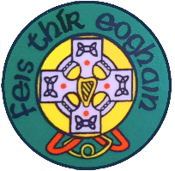
The Poetry, Prose & Drama Section of the West Tyrone Feis took place this week and we congratulate all our wonderful pupils who took part in the various competitions. Next week the classical music section will begin on Monday, 15th April and culminate with the school choirs on the morning of Friday 19th April. The traditional music section will take place on Saturday 27th April. For parents’ convenience the Feis timetable is available to view on the main page of our school website under ‘More News’ and all events will take place in St. Joseph’s Hall. Pupils have also been issued with a Feis card which will contain all the details relating to each event – these cards MUST be taken on the day to compete in the competition. We wish all our competitors the best of luck and know they will do themselves, their families & Holy Family proud!!!
Omagh Youth Centre
Omagh Youth Centre Juniors club for young people aged 9-11 from 6.30pm – 9.00pm runs each Friday night. All sessions are free of charge and all members need to have completed a registration form to attend. A number of our pupils are already registered, but new members are more than welcome to attend!! For more information please contact Bronagh on bronagh.mcelroy@eani.org.uk or telephone 028 822 49349.

The Phantom of the Opera
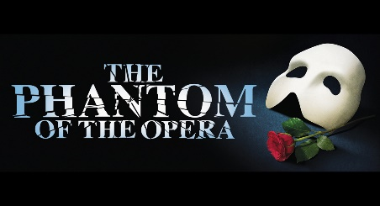
All roads lead to the Strule Arts Centre this weekend for Andrew Lloyd Webber’s highly acclaimed musical Phantom of the Opera which is being performed by The Golden Apples Players (Ex. Hazel Wanders!!). The show opened on Wednesday night and is receiving rave reviews throughout the local community. There are quite a few of our past pupils involved so if you haven’t already secured your tickets, you need to move quickly as there is very little availability left!!! Booking is online through the Strule Arts Centre website or by telephone (8224 7831) and seats are priced at £18.00 each.

Thought for the Week

Whether you think you can,
or whether you think you can’t –
you’re right!!!

