Holy Family Primary School
Newsletter
Friday, 26th April 2024
Pupils of the Week
Class | Name | Reason
Reception | Maeve McCarron  Caiden Campbell | For her creative pattern with playdough  For his wonderful ‘mark making’
Yr.1 NC | Noah Doherty | For being such a lovely friend to everyone
Yr.1 MP | Tess McMacken | For writing amazing sentences all about Space!
Yr.2 EM | Georgia Leeper | For accurately calculating change in our money topic!
Yr.2 FMG/NC | Tiernan McConnell | For his detailed writing about his favourite fairy tale
Yr.3 SM | Thomas Kearney | For being such a consistently hard worker & for being a role model in class
Yr.3 MC | Amelia-Rose Anthony | For her enthusiastic attitude towards our ‘Big Spring Clean’
Yr.4 CMM | Maryam Ahmad | For her wonderful use of adjectives for ‘Fantastic Mr. Fox’
Yr.4 BH | Ella Taggart | For consistently working hard & having a great attitude to school
Yr.5 DMC | Jake McGuire | For great work on ’24 hour’ time
Yr.5 DMS | Dearbla Darcy | For excellent work on the ’24 hour’ clock
Yr.6 SMG | Laura Crumlish | For having a great work ethic
Yr.6 ZMD | Lilah McCrossan | For working so hard on Junior English Revised
Yr.7 CK | Fergal Ferris | For always giving 100% and for always listening
Yr.7 KMK/AC | Lily O’Neill | For her excellent work on ‘Angles’ in her Numeracy

Good Manners Award
Those chosen to receive recognition for the ‘Good Manners’ Award this week are:
Junior Site: Cora Gribben, Annabelle Sweeney, Ethan McGloin, Thielen Douglas, Molly Corcoran, Finn McKnight, Padraig Shields, Renan Ferad, Anna McEnhill, Natalie Nagyova, Brody Watson & Mollie-Kate McConnell.
Senior Site: Keelan Mackey, James McCarron, Isla Maxwell, Sarah McEnhill, Darragh McMahon, Joseph Tierney, Reuben McGee, Molly Mullan & Lorcan Murphy.
Well done everyone, we are so proud of you all.

Healthy Eaters!
Junior Site: Raisa-Maria Tigau, Abigail Anthony, Fiadh-Mae Slattery, Iana Kelly Starrs, Vanessza Cseh-Matyasovszky, Caoimhe Gallagher Neill, Seamus McCreesh & Mollie-Kate McConnell.
Senior Site: Danny Molloy, Rionagh McMahon, Reilly Slattery, Darragh McMahon, Alan Karol & Myah Donnelly.
Congratulations everyone – keep up the good work!!
Upcoming Dates to Note
Mon 6th – Fri 10th May – Mid-term break. School closed for the week
Wed 15th May – Sacrament of Confirmation at 5.00pm in Sacred Heart Church
Sat 18th May – First Holy Communion at 12noon in Sacred Heart Church

Reminder: Blocking School Entrances
Parents/guardians are asked not to block the entrances/gates to the school when dropping off/collecting children. This has become an issue on the senior site in recent weeks when collecting from after school clubs, resulting in members of staff being kept late for apppointments! We thank you for your understanding & support in this matter.

Holy Family ‘Sporting News’
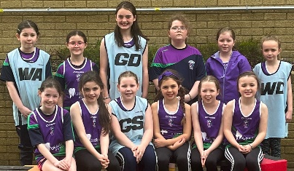
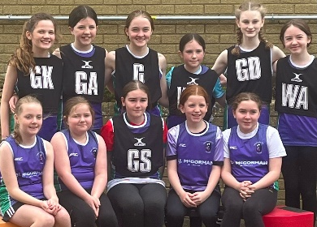
Netball: Huge congratulations to our super netballers who took part in St. Conor’s netball tournament yesterday. We had two teams of girls who played against teams from St. Mary’s Killyclogher, Omagh Integrated, Christ the King, St. Ronan’s Recarson, St. Conor’s and St. Joseph’s Drumquin!!! It was an amazing display of netballing skills and we were delighted that one of our teams made it to the final against Recarson. The score was 6 all at full time but unfortunately we were pipped at the post in extra time!!! We sincerely thank our P.E. Co-0rdinator Ms. McSorley and our after school coach Siobhan Mullin for all their hard work with the girls. Congratulations again girls – you are a credit to yourselves, your school and your families.
Gaelic: Today, Mr. McCusker has a number of our K.S.2 pupils out in Healy Park to take part in Christ the King’s Gaelic tournament. We’ve no doubt there will be some hard fought battles on the field of play and we will let you know in next week’s newsletter how they get on!!

Basketball/Netball on Junior Site
We wish to inform our Yr.3/4 parents that due to low numbers the basketball/netball after school club on Tuesdays will no longer take place. Parents may still avail of the Yr.3/4 waiting over club if they need their child to remain in school until 4.00pm. Online booking for all our after-school clubs is available from 3.00pm each Thursday until midnight each Sunday and children must be booked through this to attend the clubs. If you encounter any difficulties when booking please contact Anne on 028 8224 3551 first thing on Monday morning for assistance.

Apprentice Connect - South West College
If you or any of your family/friends are interested in an apprenticeship programme at South-West College in September 2024 you are invited to come along to ‘Apprentice Connect’ and find out more about Apprenticeships, Higher Level Apprenticeships and Traineeships. You will have the opportunity to meet employers and speak to college staff to find out more about the range of courses available. Apprentice Connect takes place on the following dates: Omagh Campus Tuesday, 30th April - Dungannon Campus Wednesday, 1st May and the Skills Centre Enniskillen Thursday, 2nd May

Thought for the Week

Never give up on the
things that make you smile!!

